Project Planning Phase

**Project Planning Template (Product Backlog, Sprint Planning, Stories, Story points)**

|  |  |
| --- | --- |
| Date | 2 November 2022 |
| Team ID | PNT2022TMID43621 |
| Project Name | Plasma Donor Application |
| Maximum Marks | 8 Marks |

Product Backlog, Sprint Schedule, and Estimation (4 Marks)

|  |  |  |  |  |  |  |
| --- | --- | --- | --- | --- | --- | --- |
| **Sprint** | **Functional**  **Requirement (Epic)** | **User Story Number** | **User Story / Task** | **Story Points** | **Priority** | **Team Members** |
| Sprint-1 | Registration | USN-1 | A user can register for the application by entering their email, password, and confirming the password. | 3 | High | * Praveen Kumar * Mridula * Saranraj |
| Email verification | USN-2 | A user will receive confirmation email once they have registered for the application. | 3 | High | * Arun * Fenisha Princess * Mridula |
| Login | USN-3 | A user can log in and enter the application by proceeding with email & password. | 2 | High | * Fenisha Princess * Arun |
| Donor/Recipient Profile | USN-4 | A user is able to register themselves as verified plasma donor or a recipient. | 3 | High | * Arun * Mridula |
| Sprint-2 | Virtual Certificate | USN-5 | A user will get a virtual donation certificate after a verified successful Plasma donation. | 2 | Medium | * Fenisha Princess * Saranraj |

|  |  |  |  |  |  |  |
| --- | --- | --- | --- | --- | --- | --- |
| **Sprint** | **Functional**  **Requirement (Epic)** | **User Story Number** | **User Story / Task** | **Story Points** | **Priority** | **Team Members** |
|  | Plasma Request | USN-6 | A verified clinic can make a Plasma request through the application. | 3 | High | * Fenisha Princess * Arun * Saranraj |
| Verification of Donor’s details | USN-7 | We the administrators will verify the details provided by the donor/ recipient are correct for a genuine Plasma donation or plasma recipient. | 2 | Medium | * Mridhula * Arun * Fenisha Princess |
| Sprint-3 | Accept the donation request | USN-8 | A user and a registered donor will get a notification to accept the plasma request for their specific blood type. | 3 | High | * Praveen Kumar * Saranraj |
| Communication Channel | USN-9 | A patient is able to communicate with the donor personally within the application. | 3 | Medium | * Mridula * Fenisha Princess |
| Share  Location | USN-10 | A user and a registered donor is able to share their location with the  recipient after accepting their Plasma request. | 3 | Medium | * Arun * Praveen Kumar * Fenisha Princess |
| Administrator | USN-11 | An admin will store the registered donors and recipients details after their verification into the database. | 3 | High | * Arun * Fenisha Princess * Mridula |
| Sprint-4 | Support | USN-12 | A user is able to ask basic question  related to plasma donation/ Plasma recipient with the help of chat-bot. | 2 | Medium | * Saranraj * Fenisha Princess * Arun |

|  |  |  |  |  |  |  |
| --- | --- | --- | --- | --- | --- | --- |
| **Sprint** | **Functional**  **Requirement (Epic)** | **User Story Number** | **User Story / Task** | **Story Points** | **Priority** | **Team Members** |
|  | About | USN-13 | A new user can use the About page to know information and details related to Plasma donation and benefits. Also the details of Plasma. | 2 | Medium | * Praveen Kumar * Saranraj * Mridula |
| Administrator | USN-14 | An admin will approve all the Plasma transaction in the application after every proper verification and will update the Plasma availability and donors count periodically. | 3 | High | * Arun * Fenisha Princess * Praveen Kumar |

Project Tracker, Velocity & Burndown Chart: (4 Marks)

|  |  |  |  |  |  |  |
| --- | --- | --- | --- | --- | --- | --- |
| **Sprint** | **Total Story Points** | **Duration** | **Sprint Start Date** | **Sprint End Date (Planned)** | **Story Points Completed (as on Planned End Date)** | **Sprint Release Date (Actual)** |
| Sprint-1 | 20 | 6 Days | 24 Oct 2022 | 29 Oct 2022 | 18 | 03 Nov 2022 |
| Sprint-2 | 20 | 6 Days | 31 Oct 2022 | 05 Nov 2022 | 20 | 09 Nov 2022 |
| Sprint-3 | 20 | 6 Days | 07 Nov 2022 | 12 Nov 2022 | 18 | 15 Nov 2022 |
| Sprint-4 | 20 | 6 Days | 14 Nov 2022 | 19 Nov 2022 | 18 | 21 Nov 2022 |

Velocity:

Imagine we have a 10-day sprint duration, and the velocity of the team is 20 (points per sprint). Let’s calculate the team’s average velocity (AV) per iteration unit (story points per day)

***AV = Sprint Duration / Velocity = 24 / 20 = 1.2***

Total number of days = sprint 1 + sprint 2 + sprint 3 + sprint 4 = 6 + 6 + 6 + 6 = 24

Total number of story points = 18 + 20 + 18 + 18 = 74

Average velocity per sprint = 74 / 24

~= 3.083333

= 3

**Burndown Chart:** A burn down chart is a graphical representation of work left to do versus time. It is often used in agile [software development](https://www.visual-paradigm.com/scrum/what-is-agile-software-development/) methodologies such as [Scrum.](https://www.visual-paradigm.com/scrum/scrum-in-3-minutes/) However, burn down charts can be applied to any project containing measurable progress over time.

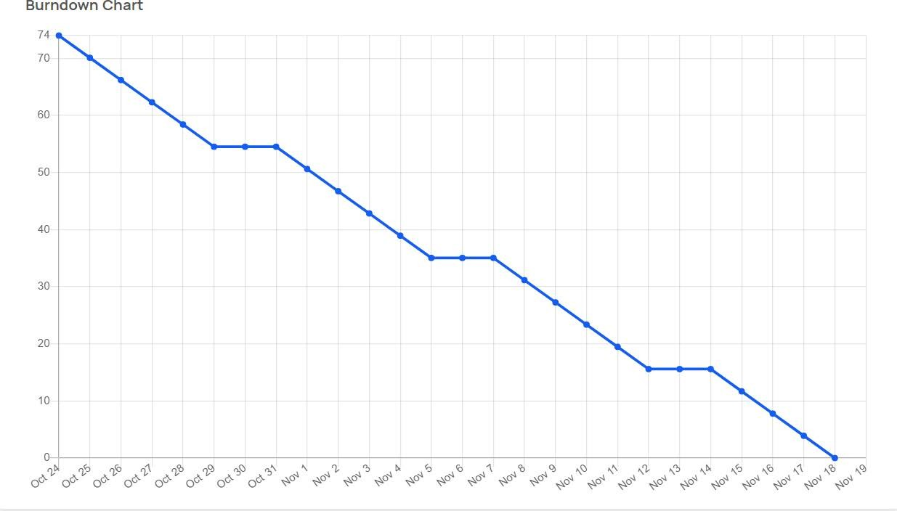

Estimated Burndown Chart